Milestone 3 Worksheet

In this milestone, you will use your knowledge from Statistics to take a closer look at the value of your home and whether it is priced competitively. You will sample houses that are similar to your own in your city of choice and use these houses to investigate the value of your property.

Part I: Selecting a Sample

For this section of the project, think about how you will select your sample. You will then use this sample to estimate how much your property is worth and whether it is above/below market value. Use zillow.com to search for homes that have been recently sold in your target area.

Before you start searching, determine how you should select comparable homes. Are you going to look throughout the entire city, or will you limit your search to a specific neighborhood or zip code? Explain in at least three sentences below:

Next select at least ten comparable homes to serve as your sample size. These homes should have similar (or at least pretty close) features as your home, such as: number of bedrooms, bathrooms, square footage, etc. We will use your sample to estimate the value of similar homes in your neighborhood. Make sure to include the data for the house you selected for Milestone 1.

Homes | Sale Prices | Features | Square Feet | Price Per Sq. Foot (PPSF)
Your House
Comp 1 | $ | ex. 3br, 2bath, condo
Comp 2 | $
Comp 3 | $
Comp 4 | $
Comp 5 | $
Comp 6 | $
Comp 7 | $
Comp 8 | $
Comp 9 | $
Comp 10 | $

Part 2: Finding your Sample Parameters

Using your sample above, let’s calculate some measures of central tendency. Zillow lists median property values for each neighborhood on their website, which will be helpful in seeing if our sample is representative of our population.

- Calculate and explain how to find the mean of your sample.

- Calculate and explain how to find the median of your sample.

- What is the median price for similar homes listed in your neighborhood? (find this on Zillow): $___________
- What is the sampling error for the median (the difference between the Zillow median and your sample median) of your ten homes? $___________

Given your sampling error, do you think your sample is representative of the market in your city/neighborhood? Explain in 2-3 sentences below.

Now we are going to look at the price per square foot (PPSF) of your properties. Let’s find the mean, variance, and standard deviation for these homes.
List the price per square foot for your properties to the right:
Next find the mean price per square foot of your properties: ___________

Now for the calculations! Show all of your work to find the variance below (note that n=9, since this is a sample… remember that n is the number that you divide by in the formula)

Finally take the square root of your variance to find the sample standard deviation:

Part 3: Using your Sample to Guess Whether your Property is a Good Deal!

Now let’s put everything together to make some inferences on our house. Below you will see a normal curve and some empty boxes. Remember that the funky looking $σ$ character stands for Standard Deviation. Fill in the empty boxes, using your PPSF data you constructed above. Remember your mean goes in the middle box and you’ll use your standard deviation from Part 2 to fill out the rest. If your word processor does not allow you to fill in the boxes, please print out and fill in by hand.
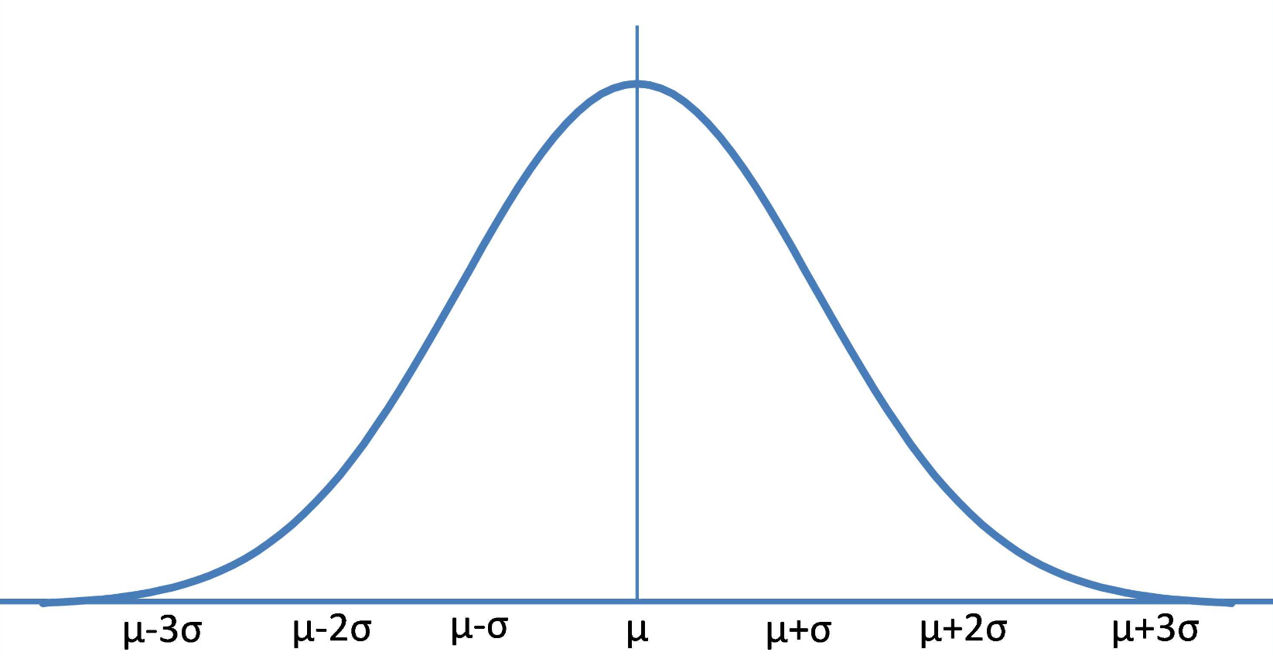

So, if my sample is pretty accurate to the entire population of houses in my neighborhood, I should expect the price per square foot of my home to be between $___ and $___ per square foot.

Now let’s assume that this normal distribution accurately reflects the prices of houses in your neighborhood. We want to find how many standard deviations away from the mean our dream house selling price lies (this is known as a z-score) and is calculated by $z=\frac{your house PPSF-mean house PPSF}{standard deviation of PPSF}$. We will then use this formula to approximate how this house compares with other properties in the area. Your z-score will most likely fall between -3 and 3, unless your house is much cheaper/more expensive than other houses.

So now, find the z-score for the dream property you identified in Milestone 1: _________

Using a z-score table, your house is more expensive than _____% of properties in your neighborhood, by estimation of your sample.

Part 4: Reflection

Please answer each of the following questions with at least 2-3 complete paragraphs per question below:

Question 1: How did the price of your house compare with other properties in the neighborhood? Was your house’s selling price higher or lower than the mean value of the entire neighborhood? What reasons might there be for your house having a different price than your comparable properties?

Question 2: Real estate appraisers use the comparable property approach to determine the value of a home. Research some of the considerations they take into account in drafting an appraisal. What kinds of sampling techniques do they use to ensure their comparable properties are representative of the population? What other factors do they take into consideration other than sale price/price per square foot?

Question 3: Given your research and your comparable properties, do you think that your house is a good deal compared to other properties? Support your reasoning with evidence from the other parts and personal research, as well as additional features of the home.

